Line Integrals

Line Integrals

Work
z
Force vector: F
Displacement vector: d
Work (a scalar): W = F•d
Work (from r to r+dr) dW = F•dr
Work along a curve C = is a line integral

If the path of integration C is a closed curve, we write
O for closed curve only
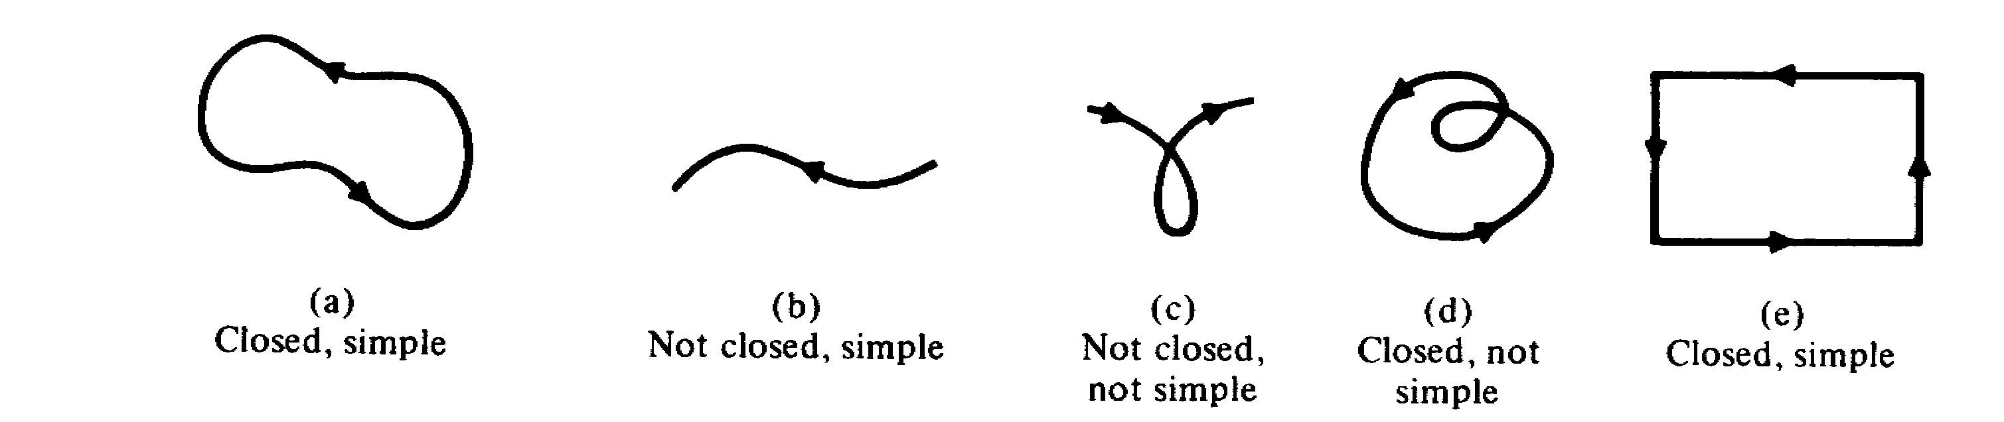

Methods of Evaluation of Line Integral

The line integration along a curve C can be evaluated in the following two methods:

Method I: Parameter Representation (of the curve)
The parametric representation of a curve r(t) is
r(t) = x(t) i + y(t) j + z(t) k
then =

[Example] Curve: y = x²
Force Field F = 2 x y i + ( x² + y² ) j
Find the work done in moving from the point (1, 1) to the point (3, 9)
[Solution] The curve C can be represented by
r(t) = t i + t² j 1 ≤ t ≤ 3
The work can be calculated by
W = =
But F(t) = 2 x y i + ( x² + y² ) j = 2 t³ i + ( t² + t⁴ ) j
and = i + 2 t j
∴ F•= 2 t³ + 2 t ( t² + t⁴ ) = 4 t³ + 2 t⁵
∴ W = = 322
[Exercise] F(x, y) = i + j
Calculate the work done for a particle which moves on
the straight line from (1, 0) to (3, -2)
[Hint]: r(t) = t i + ( 1 - t ) j , 1 ≤ t ≤ 3 Ans: W = α ( 1 - )

Method II Non-parametric Representation
If F = F_{x} i + F_{y} j + F_{z} k
and r = x i + y j + z k
then =

[Example] F = y z i + x y j + x z k
Calculate the line integral of F from (0, 0, 0) to (1, 1, 1) along the path C consisting of:
- the curve x = y², z = 0 in the xy plane from (0, 0, 0) to (1, 1, 0), and
- the line perpendicular to the xy plane from (1, 1, 0) to (1, 1, 1).

[Solution]
= +

On C₁: (0, 0, 0) to (1, 1, 0)
z = 0, x = y²
∴ dz = 0 and dx = 2 y dy
⇒ =
=
=
=
= =

On C₂: (1, 1, 0) to (1, 1, 1)
x = 1, y = 1, z = z
dx = 0, dy = 0
∴ = =

∴ = + =

Note that if we integrate along the path C' consisting of the straight line x = y = z, directly from (0, 0, 0) to (1, 1, 1), then on C'
dx = dy = dz and x = z, y = z
= = 1

which indicates that
The above line integral depends on the path of integration.

Line Integrals Independent of Path
Question: Under what condition(s) that ≠ f(path)?
Note that =
If we can somehow find a function f such that
df = F_{x} dx + F_{y} dy + F_{z} dz
then = = f(P₁) - f(P_{o})
which is independent of path if f(.) is a single-values function. Here P₁ and P_{o} are the end points of C.
Since df = dx + dy + dz (This is the Exact Differential!)
we need F_{x} = ; F_{y} = ; F_{z} =
Note that = = =
or
Similarly, we need

Next we notice that
∇ × F = i + j + k =
thus, if F satisfies the above exactness conditions, then

Theorem: Criterion for Exactness and Independence of Path
=
is independent of path in a domain D if

(i) F_{x}, F_{y}, F_{z} and their first derivatives are continuous in D.
(ii) they are exact, i.e.,
= ; = ; =
or ∇ × F = =0
(iii) D is simply connected.

Simply Connected Region
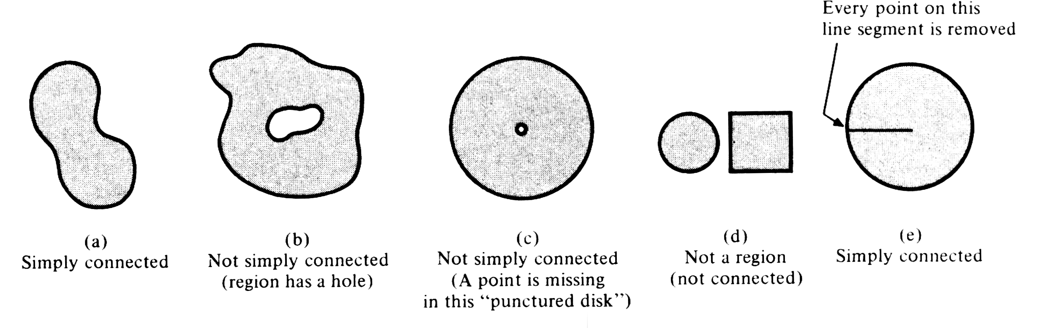

Potential Function
If we have ∇ × F = 0, then, as shown in the above section, we can find a function f such that
df = F•dr
In addition, since df = ∇f•dr
thus, df - df = ( F - ∇f )•dr = 0
i.e., either F - ∇f ⊥ dr, or F - ∇f = 0 must be true. But since the direction of dr is arbitrary, we have
F = ∇f
That is,
If ∇ × F = 0 in a region, then F is the gradient of a scalar function f in that region.

The function f defined in the above equation is known as potential of F.
In this case, F and the vector field defined by F are called conservative since
O= 0

[Example] F = y² i + 2 ( x y + z ) j + 2 y k
(i) Is F conservative?
(ii) What is the potential of F
[Solution]

(i) Since ∇ × F = 0 everywhere, i.e.,
- F is conservative.

(ii) df = F•dr We need to find f such that
F = ∇f
Since df = F•dr = y² dx + 2 ( x y + z ) dy + 2 y dz
= dx + dy + dz
∴ Fx== y² ⇒ f = x y² + g(y, z)
Again, Fy= = 2 ( x y + z )
or 2 x y + = 2 ( x y + z )
⇒ = 2 z
⇒ g(y, z ) = 2 y z + h(z)
or f = x y² + 2 y z + h(z)
Now since
Fz== 2 y
⇒ 2 y + = 2y
⇒ h(z) = C , an arbitrary constant
∴ f = x y² + 2 y z + C

[Example] F = - i + j
F•dr = = d tan⁻¹ = dθ
Thus, we have
F = ∇f f=tan⁻¹
and ∇ × F = 0
But is F conservative?
Note that |F| = and |F| → ∞ as (x, y) → (0, 0)
i.e., F is not continuous at (0, 0) and ∇×F is not defined at (0, 0).
Note that the integration
O= O= 2 π ≠ 0
if the region enclosed by curve C includes (0, 0).
Thus, condition (iii) in theorem is important!!!!

[Exercise] Show that dx + ( x + 3 z³ + x z ) dy + ( 9 y z² + x y - 1 ) dz is independent of any path C between (1, 1, 1) and (2, 1, 4). Please evaluate.
[Solution]
Since =
where F_{x} = y + y z
F_{y} = x + 3 z³ + x z
and F_{z} = 9 y z² + x y - 1
It can be easily shown that
= 1 + z = ; = 9 z² + x =
and = y =
In addition, the derivatives of F_{x}, F_{y} and F_{z} are continuous in space, we then conclude that the integral is independent of path. In order to evaluate the integral of the path from (1, 1, 1) to (2, 1, 4), we can find the potential of F first:
Since
df = F•dr = ( y + y z ) dx + ( x + 3 z³ + x z ) dy + ( 9 y z² + x y - 1 ) dz
= dx + dy + dz
⇒ f = x y + x y z + 3 y z³ - z + C
where C is an arbitrary constant. Thus
= df = x y + x y z + 3 y z³ - z + C
= 198 - 4 = 194

